NVQ LEVEL 5
Networking
Basic Concepts, IP Addressing, DNS, OSI Layers & Network Design
PROJECT | Library Automation System
The OSI 7-Layer Model
Layer 7 Application
Layer 6 Presentation
Layer 5 Session
Layer 4 Transport
Layer 3 Network
Layer 2 Data Link
Layer 1 Physical

STUDENT NAME
Farook Musarraf

IP Addressing • DNS • OSI Layers • Network Design | Unit 12 — Networking

1. Introduction
This report presents the Networking unit evidence for the Library Automation System project. It covers the basic concepts of computer networking, IP addressing, DNS, and the OSI layer model, then applies all of it to a practical exercise: a given (flawed) network topology for the library branch, and an edited, improved version of that topology with the changes documented and justified.

2. Basic Networking Concepts

2.1 Network Types
- LAN (Local Area Network): a network confined to one site, e.g. a single library branch — this project's scope.
- WAN (Wide Area Network): connects LANs across sites/cities, e.g. multiple library branches linked over the internet.
- MAN (Metropolitan Area Network): spans a city, e.g. linking branches across one town's library network.

2.2 Network Topologies
- Star: every device connects to a central switch — a single cable failure only affects one device. Used in this project.
- Bus: all devices share a single backbone cable — simple but a single break disables the whole segment.
- Ring: devices connect in a closed loop — deterministic but a single break can disrupt the ring unless dual-ring.
- Mesh: devices connect to many others directly — highly resilient but expensive to cable at scale.

2.3 Key Network Devices
Device | Role
Router | Connects the internal network to the internet (or another network) and directs traffic between them using IP addresses.
Switch | Connects devices within one LAN and forwards traffic to the correct device using MAC addresses.
Firewall | Filters traffic entering/leaving the network based on rules, blocking unauthorized access.
Access Point (AP) | Bridges wireless devices onto the wired LAN.
Server | Hosts a service other devices consume — here, the Library API and MySQL database.

3. IP Addressing
An IPv4 address is a 32-bit number, written as four decimal octets (e.g. 192.168.10.10), that uniquely identifies a device on a network. It splits into a network portion and a host portion, defined by a subnet mask (e.g. /24 = 255.255.255.0, meaning the first 24 bits identify the network and the last 8 identify the host — giving 254 usable host addresses per subnet).

3.1 Public vs Private IP Addresses
- Public IP: globally unique, routable on the internet (e.g. the ISP-assigned WAN address on the border router).
- Private IP: only valid within a local network, not routable on the internet; reused across countless private networks. Reserved private ranges: 10.0.0.0/8, 172.16.0.0/12, and 192.168.0.0/16 — this project uses the 192.168.x.0/24 range.

3.2 IPv4 Address Classes (Classful Reference)
Class | Range | Default Mask | Typical Use
A | 1.0.0.0 – 126.255.255.255 | /8 | Very large networks
B | 128.0.0.0 – 191.255.255.255 | /16 | Medium/large networks
C | 192.0.0.0 – 223.255.255.255 | /24 | Small networks (used here)

3.3 Addressing Plan Used in This Project
The edited network (Section 6.2) is segmented into three subnets, one per VLAN, rather than one flat /24 for every device:
VLAN | Subnet | Purpose | Addressing
10 — Server/Mgmt | 192.168.10.0/24 | Library Server (API + MySQL) | Static (192.168.10.10)
20 — Staff | 192.168.20.0/24 | Librarian PCs, shared printer | DHCP for PCs, static for printer
30 — Public/Member WiFi | 192.168.30.0/24 | Member devices over the guest WiFi | DHCP

4. DNS (Domain Name System)
DNS translates human-readable names (e.g. library.local) into the IP addresses computers actually use to communicate (e.g. 192.168.10.10). Without it, every user would need to remember raw IP addresses.

4.1 How a DNS Lookup Works
- 1. A staff PC's browser requests library.local.
- 2. The PC asks its configured DNS server (or the router's built-in resolver) to resolve the name.
- 3. The DNS server checks its records; for a name it doesn't know, it queries other DNS servers until it finds the authoritative answer.
- 4. The IP address (192.168.10.10) is returned to the PC, which then connects directly to the Library Server at that address.

4.2 Common DNS Record Types
Record | Purpose
A | Maps a name directly to an IPv4 address, e.g. library.local → 192.168.10.10.
CNAME | Maps a name as an alias to another name, e.g. www.library.local → library.local.
MX | Directs email for a domain to a mail server.
Applied to this project: an internal DNS entry (A record) for library.local pointing to the Library Server's static IP (192.168.10.10) lets staff reach the system by name from any staff PC, without needing to remember or retype the IP address.

5. Network Layers (OSI Model)
The OSI (Open Systems Interconnection) model describes networking as seven layers, each responsible for one part of getting data from one device to another. The diagram below maps each layer to what actually happens when a staff member searches the book catalog in this project — from the HTTP request down to the electrical signal on the wire.
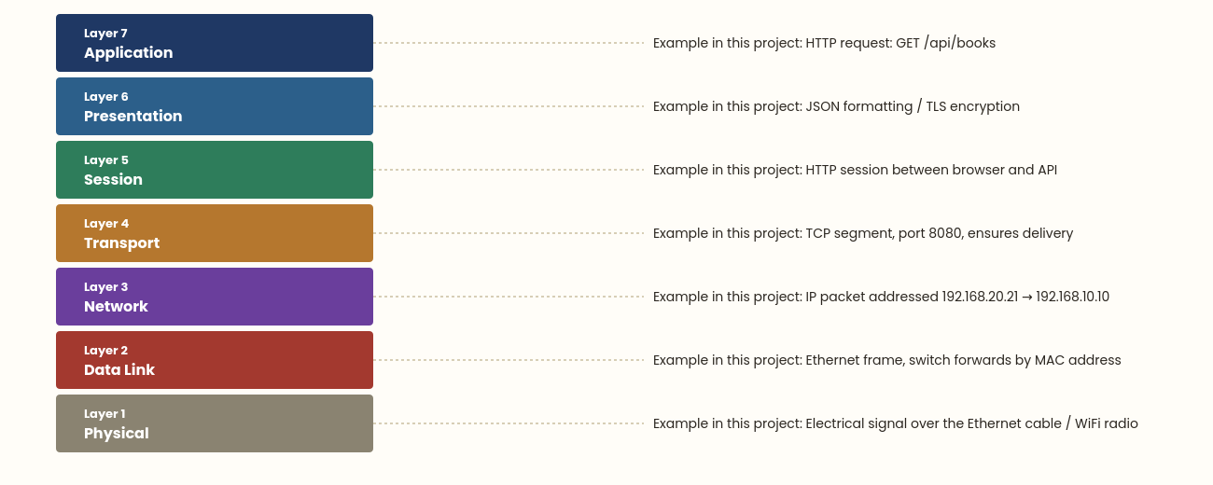
Figure 1: The OSI 7-layer model, applied to a book-search request in this project.
The TCP/IP model (the model the internet actually runs on) condenses this into four layers — Application (OSI 5-7), Transport (OSI 4), Internet (OSI 3), and Network Access (OSI 1-2) — but the seven-layer OSI model is used above as it gives a clearer teaching breakdown of where each concept (HTTP, TCP, IP, Ethernet) sits.

6. Practical Network Design

6.1 Given Network
The starting topology for this exercise: every device — the server, all staff PCs, the printer, and even a public member kiosk — sits on a single flat /24 network behind one unmanaged switch, with no firewall between the internet and the internal network.
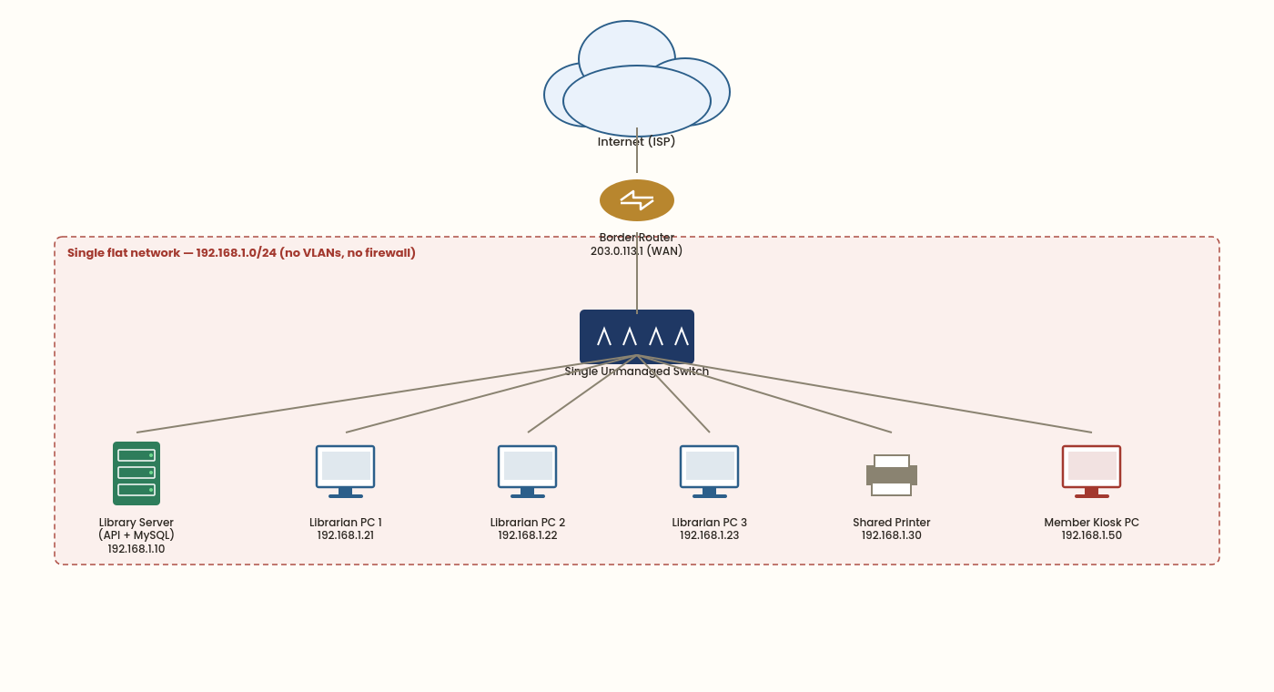
Figure 2: Given network — flat, unsegmented topology.

6.2 Problems With the Given Network
- No firewall: the border router connects straight to the internet with no filtering, exposing every internal device.
- No segmentation: the public member kiosk sits on the exact same subnet as the Library Server and staff PCs, so a compromised kiosk could reach the database directly.
- Single point of failure: one unmanaged switch carries all traffic; its failure takes down the entire library network at once.
- No structured addressing: all 254 possible addresses on one /24 are shared by every device type, making troubleshooting and access-control rules harder to write.

6.3 Edited Network
The topology was edited to address each problem above: a firewall now sits between the ISP and the internal network, and the single flat subnet was replaced with three VLANs — one for the server, one for staff, and one for public/member WiFi — each on its own /24 subnet, connected through a managed core switch.
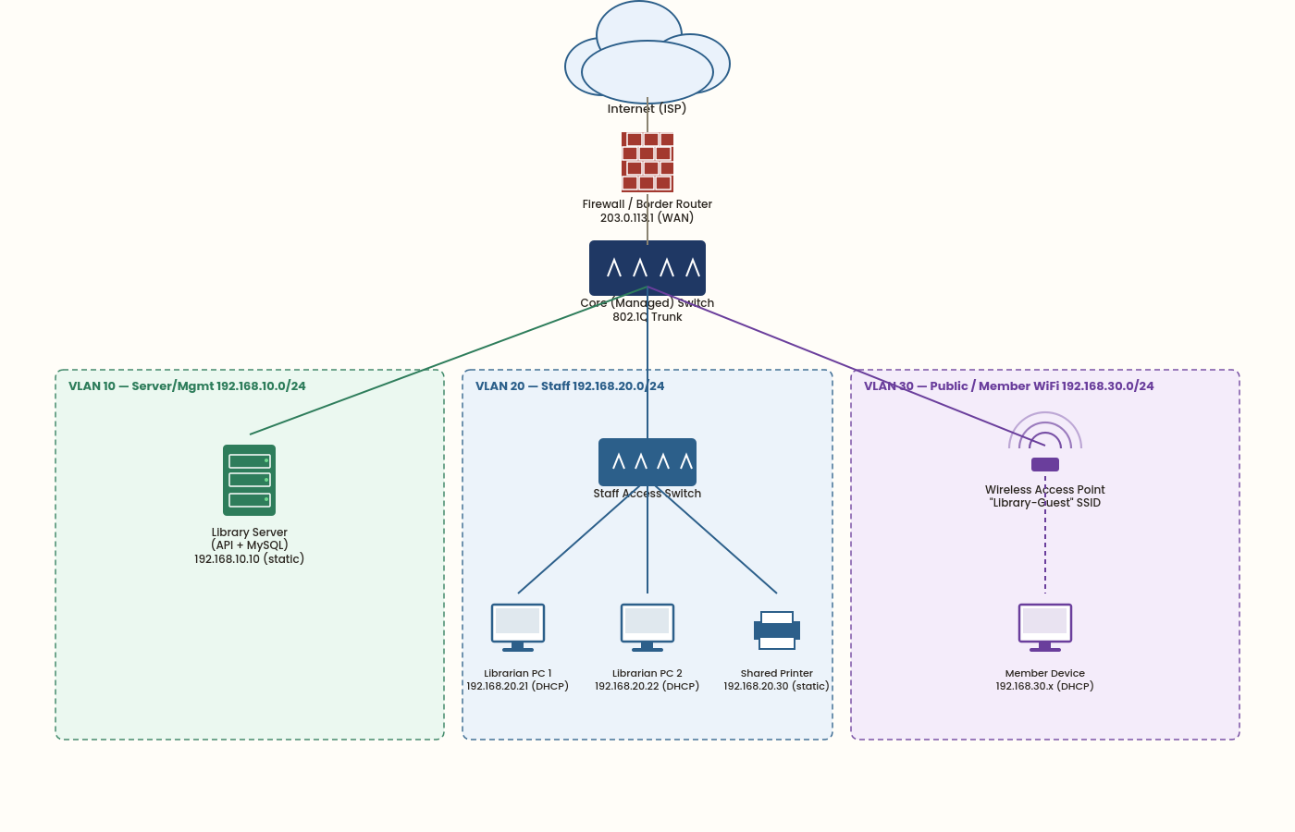
Figure 3: Edited network — VLAN-segmented topology with a firewall.

6.4 Change Log
# | Change | Reason
1 | Replaced the border router with a firewall/router | Blocks unauthorized inbound traffic from the internet before it reaches any internal device.
2 | Split the flat network into 3 VLANs (10/20/30) | Isolates the public member WiFi from the staff network and the server, limiting what a compromised guest device can reach.
3 | Moved the Library Server onto its own Server/Mgmt VLAN with a static IP | Reduces the server's exposure and gives it a predictable, memorable address for the library.local DNS entry.
4 | Replaced the single unmanaged switch with a managed core switch + a staff access switch | Removes the single point of failure for all traffic and enables VLAN trunking between switches.
5 | Added a dedicated Wireless Access Point on VLAN 30 for members | Gives members self-service catalog access without placing their devices on the staff/server network.
6 | Assigned DHCP scopes per VLAN (static only for the server and printer) | Simplifies address management for end-user devices while keeping infrastructure devices' addresses predictable.

7. Conclusion
This report has covered the basic concepts, IP addressing, DNS, and OSI-layer theory needed to understand how the Library Automation System's network operates, then applied that theory practically: identifying concrete security and reliability problems in a flat, unsegmented network, and redesigning it into a VLAN-segmented, firewalled topology with a documented, justified change log.

